15.68: (a) The displacement of the string at any point is 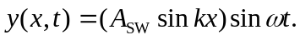 For the fundamental mode 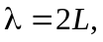 so at the midpoint of the string 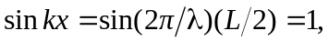 and
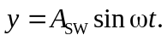 Taking derivatives gives 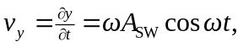 with maximum value 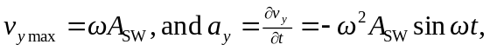 with maximum value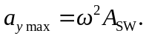 Dividing these gives and then

(b)

